 | 7.3.10 Editors - 3D Viewport - Sidebar - Tool Tab - Particle Edit Mode
Table of content
Tools Tab in Particle Edit Mode 2
Particle Edit Mode - Options panel 2
Particle Edit Type 3
X Mirror 3
Preserve Strand Lengths 3
Preserve Root Positions 3
Auto-Velocity 3
Cut particles to Shape 3
Viewport Display 3
With Hair 3
Path Steps 3
Children 3
With Emitter 3
Path Steps 3
Particles 4
Fade Time 4
Frames 4

Tools Tab in Particle Edit Mode
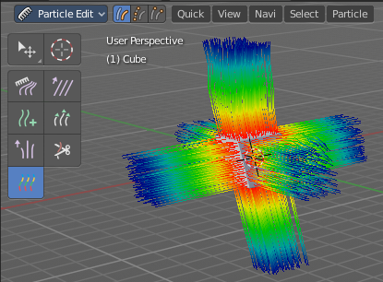
The Particle Edit mode enables to edit particle settings. For example, Hair Particles can be manipulated with some brushes. They can be combed, cut etc.

The Tools tab contains the settings for the hair editing brushes.

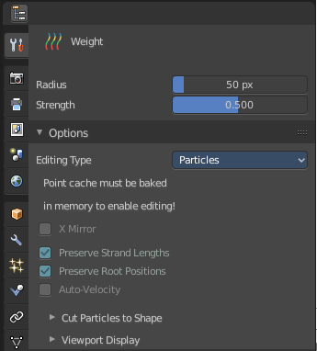
Different from the other paint modes, there is no brush panel. The brushes are here part of the tool settings of the single brushes. The brush settings will be covered in the 3D view in the chapter for Particle Edit Mode.

Particle Edit Mode - Options panel

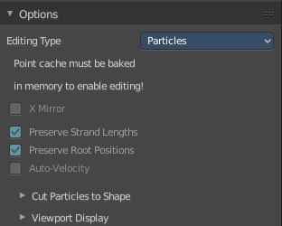
This panel contains some further options for the particles.

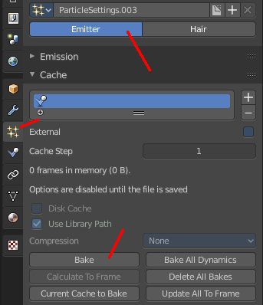
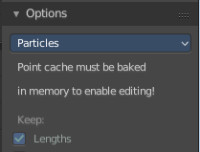
Note that you need to bake some particle types to be able modify them. Emitter for example. You will get a warning then, and the Options panel content is greyed out.

The particles can be baked in the Particles tab in the Cache panel.

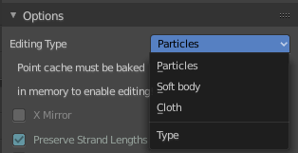

Particle Edit Type
The Particle Edit Type. This edit box just shows you what particle type you currently have. It does not allow you to change the particle type.

X Mirror
Mirrors the selected particles.
If you want a symmetrical haircut, first select all particles, then mirror the particles, then tick X Mirror.

Preserve Strand Lengths
Keep the path lengths constant.

Preserve Root Positions
Keep root keys unmodified.

Auto-Velocity
Calculate Point Velocity automatically.

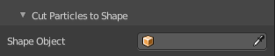
Cut particles to Shape
Define an object to cut the hair particles into the shape of the object.

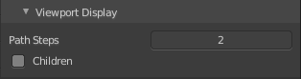
Viewport Display

With Hair

Path Steps
How many steps to display the path with. Meant is the resolution for the hair strains.

Children
Display all particles, including children. For performance reasons child particles are usually not displayed in the viewport.

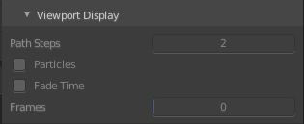
With Emitter

Path Steps
How many steps to display the emitter path with.

Particles
Display the actual particles.

Fade Time
Fade paths and keys further away from the current frame

Frames
How many frames to fade.

